On the website:

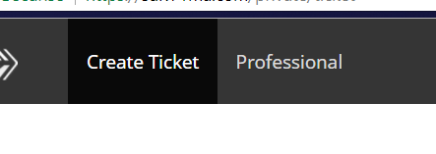

French part:

Change “Create ticket” by “PARTICULIER”

Change “Professional” by “ PROFESSIONNEL”

English part:

Change “Create ticket” by “SPECIFIC CUSTOMER”

Change “Professional” by “PROFESSIONAL”